**Design of Inverting, Non Inverting summing amplifiers, difference amplifier and op amp integrator and op amp differentiator**

**Exp No: 2 Date: 13/02/2021**

**Objective:**

To design, simulate and verify Inverting, Non-Inverting summing amplifier, difference amplifier circuits and op amp integrator and op amp differentiator.

**Software Required:**

LT SPICE - XVII

**Theory:**

**Inverting Summing Amplifier: -**

The most commonly used Summing Amplifier is an extended version of the Inverting Amplifier configuration i.e., multiple inputs are applied to the inverting input terminal of the Op Amp, while the non-inverting input terminal is connected to ground. Due to this configuration, the output of Voltage Adder circuit is out of phase by 180o with respect to the input.

Normal Inverting Amplifier circuit has only one voltage / input at its inverting input terminal. If more input voltages are connected to the inverting input terminal as shown, the resulting output will be the sum of all the input voltages applied, but inverted.

[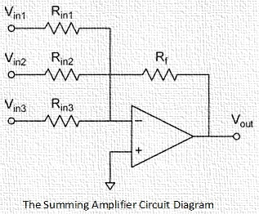](https://www.electronicshub.org/wp-content/uploads/2015/01/1.-Summing-Amplifier-Ckt.jpg)

Before analysing the above circuit, let us discuss about an important point in this setup: The concept of Virtual Ground. As the Non-Inverting Input of the above circuit is connected to ground, the Inverting Input terminal of the Op Amp is at virtual ground. As a result, the inverting input node becomes an ideal node for summing the input currents.

The circuit diagram of a summing amplifier is as shown in the figure above. Instead of using a single input resistor, all the input sources have their own input drive resistors. A circuit like this amplifies each input signal. The gain for each input is given by the ratio of the feedback resistor Rf to the input resistance in the respective branch.

**Inverting Summing Amplifier Output Voltage Calculation: -**

Let R1 be the input impedance and V1 be the input voltage of the first channel. Similarly, R2 – V2 for second channel, R3 – V3 for third channel and so on up to Rn – Vn for nth channel.

It is already been said that a summing amplifier is basically an Inverting Amplifier with more than one voltage at the inverting input terminal. The output voltage for each channel can be calculated individually and the final output voltage will be the sum of all the individual outputs.

To calculate the output voltage of a particular channel, we have to ground all the remaining channels and use the basic inverting amplifier output voltage formula for each channel.

If all the channels are grounded except the first channel, then output for first channel is given by:

VOUT1 = – (RF / R1) * V1

Where, – (RF / R1) is the voltage gain for first channel (AV1).

Similarly, if all the channels are grounded except the second channel, then output for second channel is given by:

VOUT2 = – (RF / R2) * V2

Where, – (RF / R2) is the voltage gain for second channel (AV2).

Likewise, the output for nth channel is given by:

VOUT-N = – (RF / Rn) * Vn

And – (RF / Rn) is the voltage gain for nth channel (AVn).

The output signal is the algebraic sum of individual outputs or in other words it is the sum of all the inputs multiplied by their respective gains.

VOUT = VOUT1 + VOUT2 + . . . + VOUT-N

VOUT = – [(RF / R1) * V1 + (RF / R2) * V2 + . . . + (RF / Rn) * Vn]

VOUT = V1 * AV1 + V2 * AV2 + . . . + Vn * AVn

In a summing amplifier, if the input resistances are not equal, the circuit is called a Scaling Summing Amplifier. But if all the input resistances are chosen to be of equal magnitude, then the Summing Amplifier is said to be having an equal-weighted configuration, where the gain for each input channel is same.

Sometimes, it is necessary to just add the input voltages without amplifying them. In such situations, the value of input resistance R1, R2, R3 etc. must be chosen equal to that of the feedback resistor Rf. As a result, the gain of the amplifier will be unity. Hence, the output voltage will be an addition of the input voltages.

Theoretically, we can apply as many input signals to the input of the summing amplifier as required. However, it must be noted that all of the input currents are added and then fed back through the resistor Rf, so we should be aware of the power rating of the resistors.

**Non-Inverting Summing Amplifier: -**

A Non-Inverting Summing Amplifier can also be constructed using the Non-Inverting Amplifier configuration of the Op Amp. Here, the input voltages are applied to the non-inverting input terminal of the Op Amp and a part of the output is fed back to the inverting input terminal, through voltage-divider-bias feedback.

The circuit of a Non-Inverting Summing Amplifier is shown in the following image. For the sake of convenience, the following circuit consists of only three inputs, but more inputs can be added.

[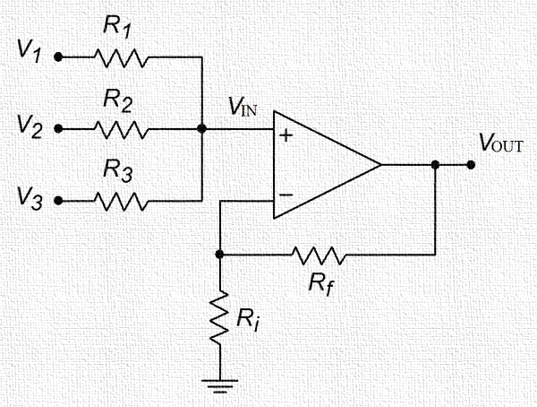](https://www.electronicshub.org/wp-content/uploads/2019/01/Non-Inv-Sum-Amp.jpg)

First and foremost, even though this is also a Summing Amplifier, the calculations are not as straight forward as the Inverting Summing Amplifier because there is no advantage of virtual ground summing node in the Non-Inverting Summing Amplifier.

**Non-Inverting Summing Amplifier Output Voltage Calculation: -**

To understand the working of a Non-Inverting Summing Amplifier, we have to divide the circuit into two parts:

1. Input Resistor / Source Section
2. Non-Inverting Amplifier Section

If VIN is the combination of all the input signals, then this is applied at the non-inverting terminal of the Op Amp. From the above circuit, we can calculate the output voltage of the Non-Inverting Amplifier with VIN as input and Rf and Ri as the feedback divider resistors as follows:

VOUT = VIN (1 + (RF / RI))

As the output voltage is figured out, we have to now determine the value of VIN. If V1, V2 and V3 are the three main input sources and R1, R2 and R3 are their input resistances, then VIN1, VIN2 and VIN3 are the inputs of respective channels when other corresponding channels are grounded. So,

VIN = VIN1 + VIN2 + VIN3

As the concept of virtual ground doesn’t apply here, all channels will have an effect on other channels. Let us calculate the VIN1 portion of the VIN and by simple mathematics, we can easily derive the other two values i.e., VIN2 and VIN3.

Coming to VIN1, when V2 and V3 are grounded, their corresponding resistors cannot be ignored as form a voltage divider network. So,

VIN1 = V1 * [(R2 || R3) / (R1 + (R2 || R3))]

Similarly, we can calculate the other two values VIN2 and VIN3 as

VIN2 = V2 * [(R1 || R3) / (R2 + (R1 || R3))]

VIN3 = V3 * [(R1 || R2) / (R3 + (R1 || R2))]

So,

VIN = VIN1 + VIN2 + VIN3

VIN = V1 * [(R2 || R3) / (R1 + (R2 || R3))] + V2 * [(R1 || R3) / (R2 + (R1 || R3))]

+ V3 * [(R1 || R2) / (R3 + (R1 || R2))]

Finally, we can calculate the Output voltage VOUT as

VOUT = VIN * (1 + (RF / RI))

 VOUT = (1 + (RF / RI)) * {V1 * [(R2 || R3) / (R1 + (R2 || R3))] + V2 * [(R1 || R3) / (R2 + (R1 || R3))] + V3 * [(R1 || R2) / (R3 + (R1 || R2))]}

If we consider the special equal weighted condition where all the resistors are having the same values, then the output voltage is:

VOUT = (1 + (Rf / Ri)) * ((V1 + V2 + V3) / 3)

Design of non-inverting summing circuit is approached by first designing the non-inverting amplifier to have the required voltage gain. Then the input resistors are selected as large as possible to suit the type of the op-amp used.

**Differential Amplifier: -**

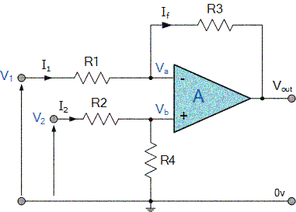

By connecting each input in turn to 0v ground we can use superposition to solve for the output voltage VOUT. Then the transfer function for a **Differential Amplifier** circuit is given as:

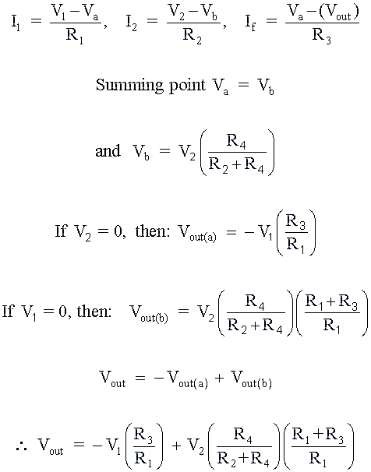

When resistors, R1 = R2 and R3 = R4 the above transfer function for the differential amplifier can be simplified to the following expression:

Differential Amplifier Equation: -

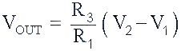

If all the resistors are all of the same ohmic value, that is: R1 = R2 = R3 = R4 then the circuit will become a **Unity Gain Differential Amplifier** and the voltage gain of the amplifier will be exactly one or unity. Then the output expression would simply be VOUT = V2 – V1.

Also note that if input V1 is higher than input V2 the output voltage sum will be negative, and if V2 is higher than V1, the output voltage sum will be positive.

The **Differential Amplifier**circuit is a very useful op-amp circuit and by adding more resistors in parallel with the input resistors R1 and R3, the resultant circuit can be made to either “Add” or “Subtract” the voltages applied to their respective inputs. One of the most common ways of doing this is to connect a “Resistive Bridge” commonly called a Wheatstone Bridge to the input of the amplifier as shown below.

Op-amp Integrator Circuit: -

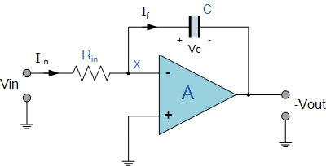

As its name implies, the **Op-amp Integrator** is an operational amplifier circuit that performs the mathematical operation of **Integration**, that is we can cause the output to respond to changes in the input voltage over time as the op-amp integrator produces an output voltage which is proportional to the integral of the input voltage*.*

In other words, the magnitude of the output signal is determined by the length of time a voltage is present at its input as the current through the feedback loop charges or discharges the capacitor as the required negative feedback occurs through the capacitor.

When a step voltage, Vin is firstly applied to the input of an integrating amplifier, the uncharged capacitor C has very little resistance and acts a bit like a short circuit allowing maximum current to flow via the input resistor, Rin as potential difference exists between the two plates. No current flows into the amplifiers input and point X is a virtual earth resulting in zero output. As the impedance of the capacitor at this point is very low, the gain ratio of XC/RIN is also very small giving an overall voltage gain of less than one, (voltage follower circuit).

As the feedback capacitor, C begins to charge up due to the influence of the input voltage, its impedance Xc slowly increase in proportion to its rate of charge. The capacitor charges up at a rate determined by the RC time constant, (τ) of the series RC network. Negative feedback forces the op-amp to produce an output voltage that maintains a virtual earth at the op-amp’s inverting input.

Since the capacitor is connected between the op-amp’s inverting input (which is at virtual ground potential) and the op-amp’s output (which is now negative), the potential voltage, Vc developed across the capacitor slowly increases causing the charging current to decrease as the impedance of the capacitor increases. This results in the ratio of Xc/Rin increasing producing a linearly increasing ramp output voltage that continues to increase until the capacitor is fully charged.

At this point the capacitor acts as an open circuit, blocking any more flow of DC current. The ratio of feedback capacitor to input resistor (XC/RIN) is now infinite resulting in infinite gain. The result of this high gain (similar to the op-amps open-loop gain), is that the output of the amplifier goes into saturation as shown below. (Saturation occurs when the output voltage of the amplifier swings heavily to one voltage supply rail or the other with little or no control in between).

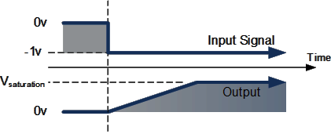

The rate at which the output voltage increases (the rate of change) is determined by the value of the resistor and the capacitor, “RC time constant”. By changing this RC time constant value, either by changing the value of the Capacitor, C or the Resistor, R, the time in which it takes the output voltage to reach saturation can also be changed for example.

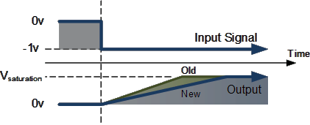

If we apply a constantly changing input signal such as a square wave to the input of an **Integrator Amplifier** then the capacitor will charge and discharge in response to changes in the input signal. This results in the output signal being that of a sawtooth waveform whose output is affected by the RC time constant of the resistor/capacitor combination because at higher frequencies, the capacitor has less time to fully charge. This type of circuit is also known as a Ramp Generator and the transfer function is given below.

Op-amp Integrator Ramp Generator: -

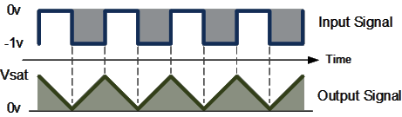

We know from first principals that the voltage on the plates of a capacitor is equal to the charge on the capacitor divided by its capacitance giving Q/C. Then the voltage across the capacitor is output Vout therefore: -Vout = Q/C. If the capacitor is charging and discharging, the rate of charge of voltage across the capacitor is given as:

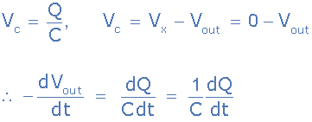

But dQ/dt is electric current and since the node voltage of the integrating op-amp at its inverting input terminal is zero, X = 0, the input current I(in) flowing through the input resistor, Rin is given as:

op-amp integrator resistor current

The current flowing through the feedback capacitor C is given as:

integrator capacitor current

Assuming that the input impedance of the op-amp is infinite (ideal op-amp), no current flows into the op-amp terminal. Therefore, the nodal equation at the inverting input terminal is given as:

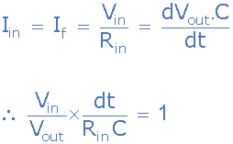

From which we derive an ideal voltage output for the **Op-amp Integrator** as:

op-amp integrator equation

To simplify the math’s a little, this can also be re-written as:

simplified integrator equation

Where: ω = 2πƒ and the output voltage Vout is a constant 1/RC times the integral of the input voltage VIN with respect to time.

Thus, the circuit has the transfer function of an inverting integrator with the gain constant of -1/RC. The minus sign (–) indicates a 180o phase shift because the input signal is connected directly to the inverting input terminal of the operational amplifier.

**The AC or Continuous Op-amp Integrator: -**

If we changed the above square wave input signal to that of a sine wave of varying frequency the **Op-amp Integrator**performs less like an integrator and begins to behave more like an active “Low Pass Filter”, passing low frequency signals while attenuating the high frequencies.

At zero frequency (0Hz) or DC, the capacitor acts like an open circuit due to its reactance thus blocking any output voltage feedback. As a result, very little negative feedback is provided from the output back to the input of the amplifier.

Therefore, with just a single capacitor, C in the feedback path, at zero frequency the op-amp is effectively connected as a normal open-loop amplifier with very high open-loop gain. This results in the op-amp becoming unstable cause undesirable output voltage conditions and possible voltage rail saturation.

This circuit connects a high value resistance in parallel with a continuously charging and discharging capacitor. The addition of this feedback resistor, R2 across the capacitor, C gives the circuit the characteristics of an inverting amplifier with finite closed-loop voltage gain given by: R2/R1.

The result is at high frequencies the capacitor shorts out this feedback resistor, R2 due to the effects of capacitive reactance reducing the amplifiers gain. At normal operating frequencies the circuit acts as an standard integrator, while at very low frequencies approaching 0Hz, when C becomes open-circuited due to its reactance, the magnitude of the voltage gain is limited and controlled by the ratio of: R2/R1.

**The AC Op-amp Integrator with DC Gain Control: -**

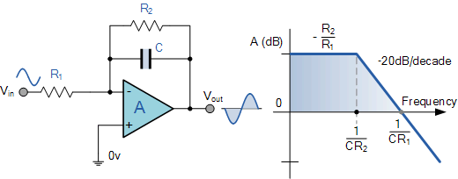

Unlike the DC integrator amplifier above whose output voltage at any instant will be the integral of a waveform so that when the input is a square wave, the output waveform will be triangular. For an AC integrator, a sinusoidal input waveform will produce another sine wave as its output which will be 90o out-of-phase with the input producing a cosine wave.

Furthermore, when the input is triangular, the output waveform is also sinusoidal. This then forms the basis of an Active Low Pass Filter as seen before in the filters section tutorials with a corner frequency given as.

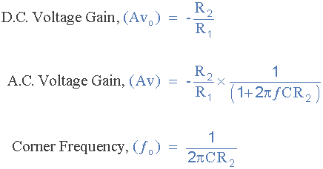

In the next tutorial about Operational Amplifiers, we will look at another type of operational amplifier circuit which is the opposite or complement of the **Op-amp Integrator** circuit above called the Differentiator Amplifier.

As its name implies, the differentiator amplifier produces an output signal which is the mathematical operation of differentiation, that is it produces a voltage output which is proportional to the input voltage’s rate-of-change and the current flowing through the input capacitor.

**Op-amp Differentiator Circuit: -**

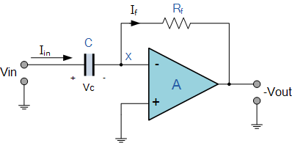

The input signal to the differentiator is applied to the capacitor. The capacitor blocks any DC content so there is no current flow to the amplifier summing point, X resulting in zero output voltage. The capacitor only allows AC type input voltage changes to pass through and whose frequency is dependent on the rate of change of the input signal.

At low frequencies the reactance of the capacitor is “High” resulting in a low gain ( Rƒ/Xc ) and low output voltage from the op-amp. At higher frequencies the reactance of the capacitor is much lower resulting in a higher gain and higher output voltage from the differentiator amplifier.

However, at high frequencies an op-amp differentiator circuit becomes unstable and will start to oscillate. This is due mainly to the first-order effect, which determines the frequency response of the op-amp circuit causing a second-order response which, at high frequencies gives an output voltage far higher than what would be expected. To avoid this the high frequency gain of the circuit needs to be reduced by adding an additional small value capacitor across the feedback resistor Rƒ.

Since the node voltage of the operational amplifier at its inverting input terminal is zero, the current, i flowing through the capacitor will be given as:

op-amp gain equation

The charge on the capacitor equals Capacitance times Voltage across the capacitor

capacitor charge

Thus, the rate of change of this charge is:

capacitor rate of change

but dQ/dt is the capacitor current*,*i

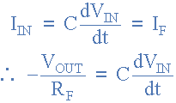

from which we have an ideal voltage output for the op-amp differentiator is given as:

op-amp differentiator equation

Therefore, the output voltage VOUT is a constant –Rƒ*C times the derivative of the input voltage Vin with respect to time. The minus sign (–) indicates a 180o phase shift because the input signal is connected to the inverting input terminal of the operational amplifier.

One final point to mention, the **Op-amp Differentiator** circuit in its basic form has two main disadvantages compared to the previous operational amplifier integrator circuit. One is that it suffers from instability at high frequencies as mentioned above, and the other is that the capacitive input makes it very susceptible to random noise signals and any noise or harmonics present in the source circuit will be amplified more than the input signal itself. This is because the output is proportional to the slope of the input voltage so some means of limiting the bandwidth in order to achieve closed-loop stability is required.

**Op-amp Differentiator Waveforms: -**

If we apply a constantly changing signal such as a Square-wave, Triangular or Sine-wave type signal to the input of a differentiator amplifier circuit the resultant output signal will be changed and whose final shape is dependent upon the RC time constant of the Resistor/Capacitor combination.

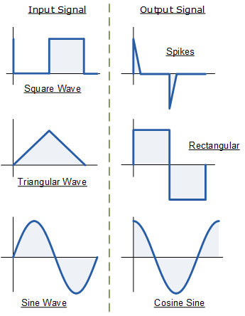

**Procedure: -**

* **Open LT Spice and click on new schematic to start the circuit making.**
* **Components needed are: wires, ground, resistor, op-amp and voltage sources.**
* **Place them all in the required way as per the requirement of circuit analysis.**
* **Perform required analysis like transient or ac analysis etc.**
* **Run the schematic once the circuit is complete**
* **Click above the ac input voltage source for the input signal**
* **Click above the load resistor to obtain the output signal.**
* **Analyse the input and output obtained from the circuit analysis on LT Spice.**
* **Save the schematic and continue further analysis if required.**

--------------------------------------------------------------------------------------------------------------------------

**Inverting Summing Amplifier: -**

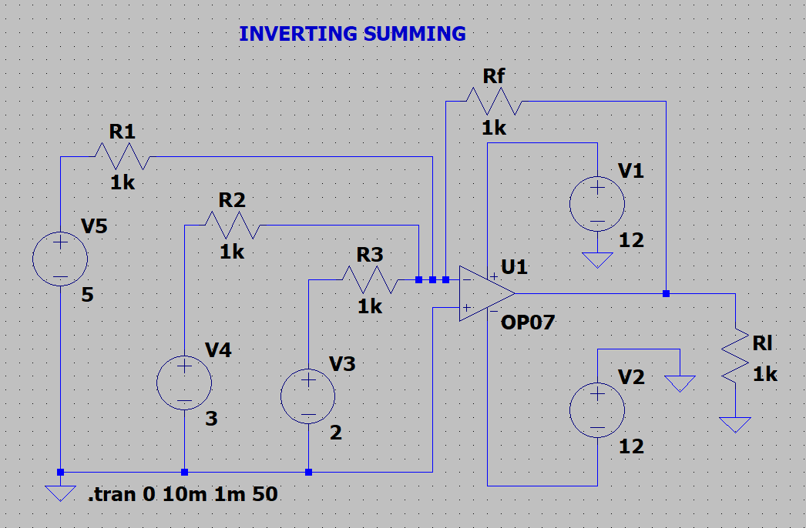

Input: -

V4, V5, V6: -

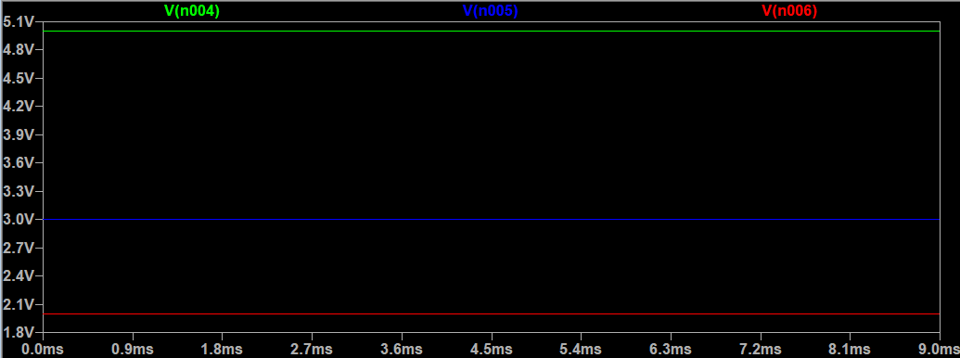

Output: -

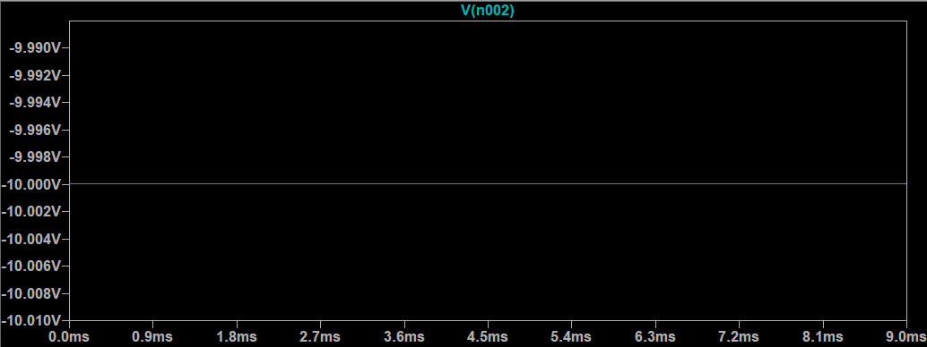

Inference: -

V1 + V2 + V3 = - (Final Output Voltage)

Here negative sign represents the output is out of phase and is inverting.

-(RF/R1) = Gain

So, the Gain is -1. Hence, we get -1 * (V1 + V2 + V3) times the output.

Now, my specifications are to get a gain of 2 Volts. So, RF/R1 should be 2. To get the output twice as required.

Calculations: -

RF/R1 = 2

RF/1K = 2

RF = 2K

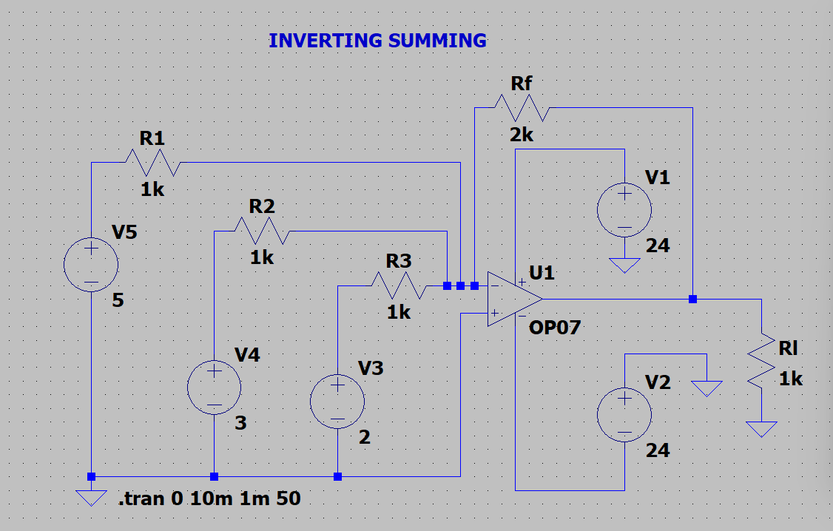

Change capacity of the battery to some higher value. As for 12 V battery is unable to give correct summing result.

Output: -

2 X -(V1 + V2 + V3) = -20V

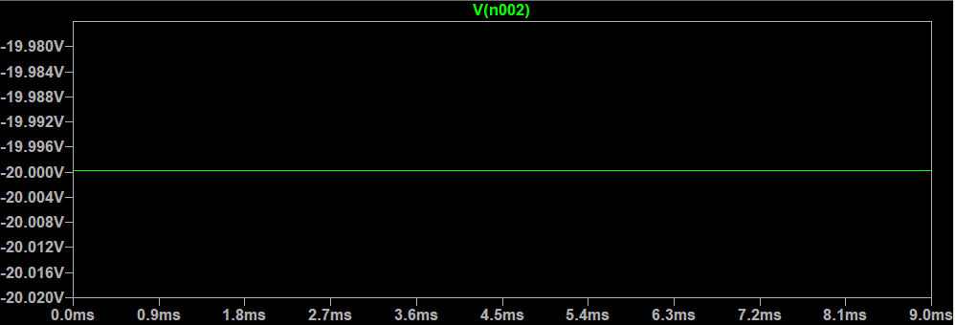

**Non-Inverting Summing Amplifier: -**

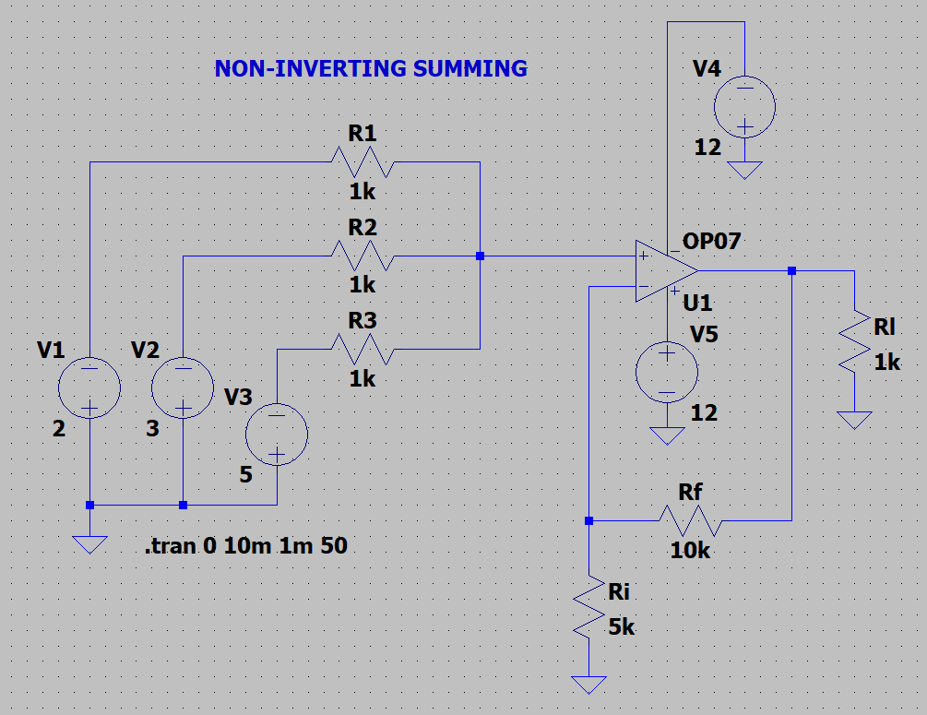

Input: -

V1, V2, V3: -

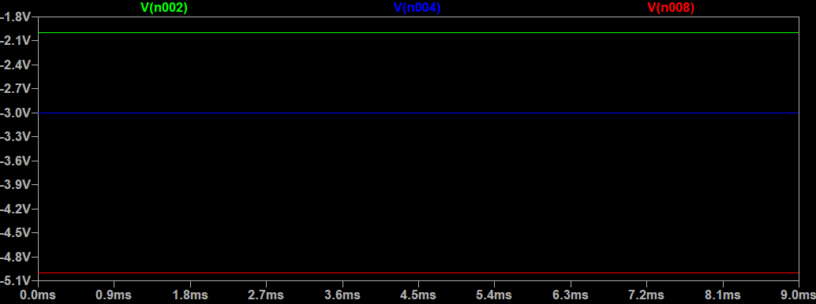

Output: -

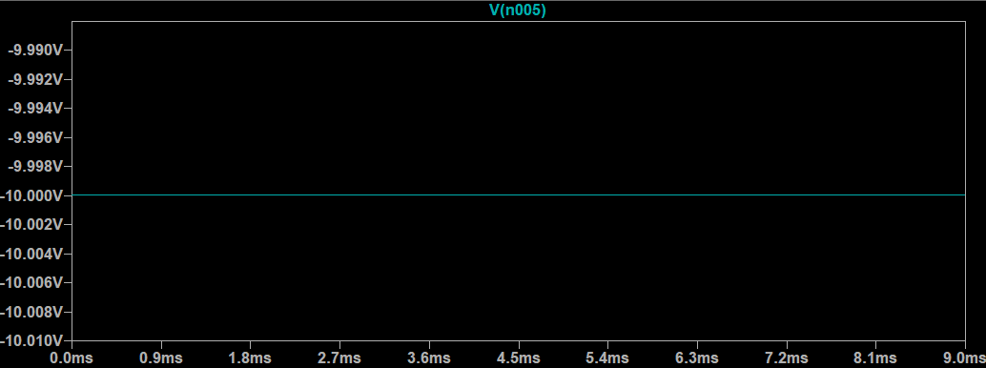

Inference: -

V1 + V2 + V3 = Voltage Output. That is, they are in “Phase”.

The Gain is 3 according to the formula, which means the gain changes by 3:1 ratio ties every time. if you want gain 1 then RF, RI should be in ratio 2:1 if you want gain 3 then RF/RI should be 5:1 further 8:1 and so on by + 3 times.

**Specification gain of 3: -**

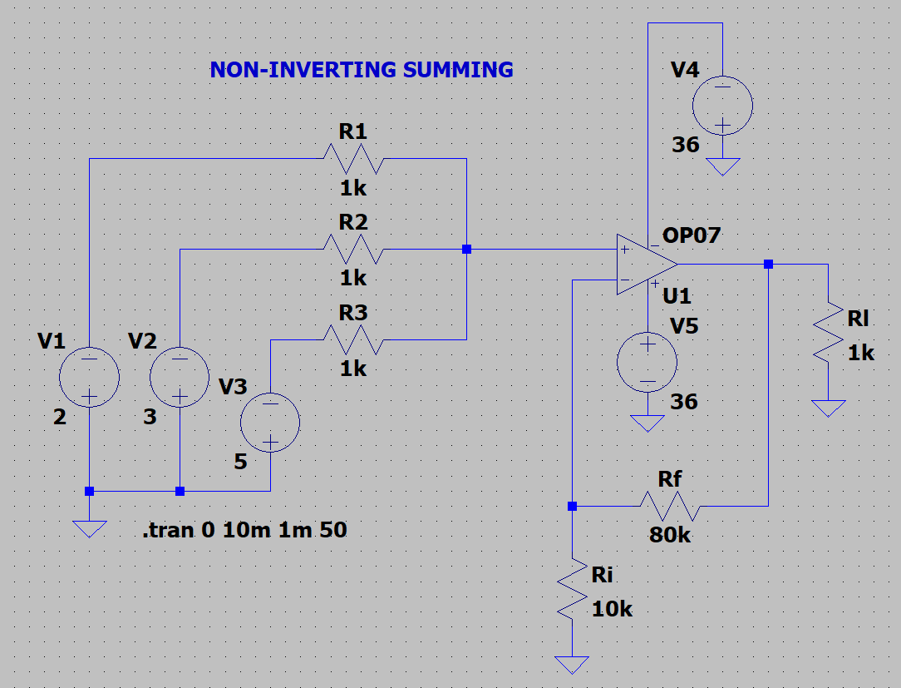

Change battery level for avoiding unreal data.

Output: -

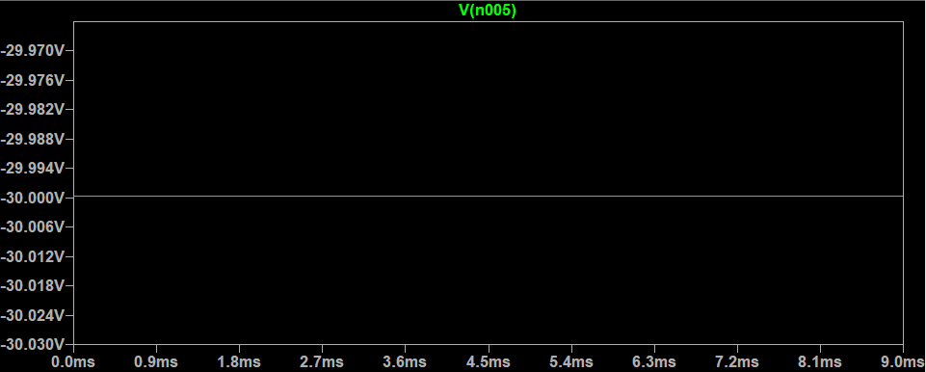

**Difference Amplifier: -**

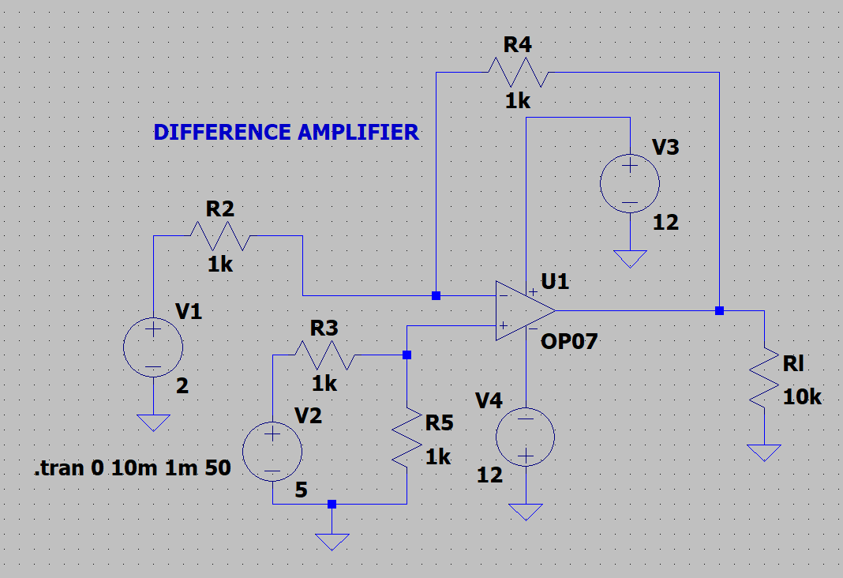

Input: -

V1, V2: -

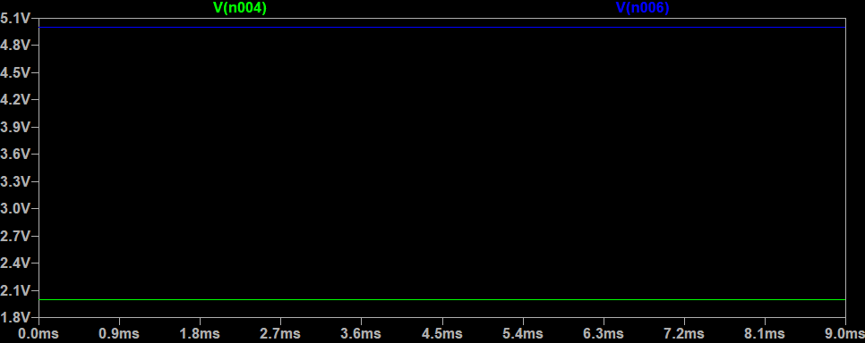

Output: -

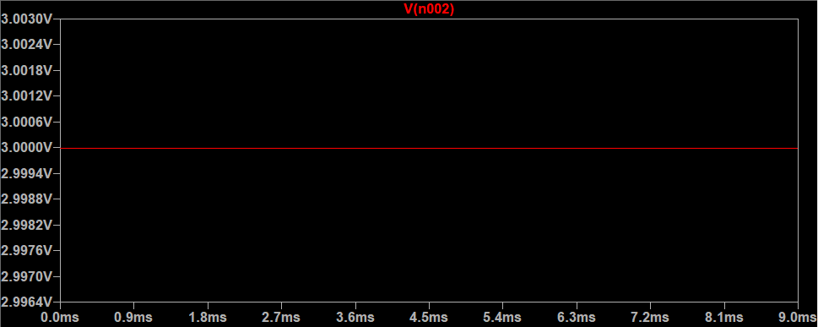

Inference: -

Output Voltage = Gain * (V2-V1)

Gain = RF/R2 - Here RF is R4

Here Gain is 1.

**OP-AMP INTEGRATOR: -**

SINE TO COS:

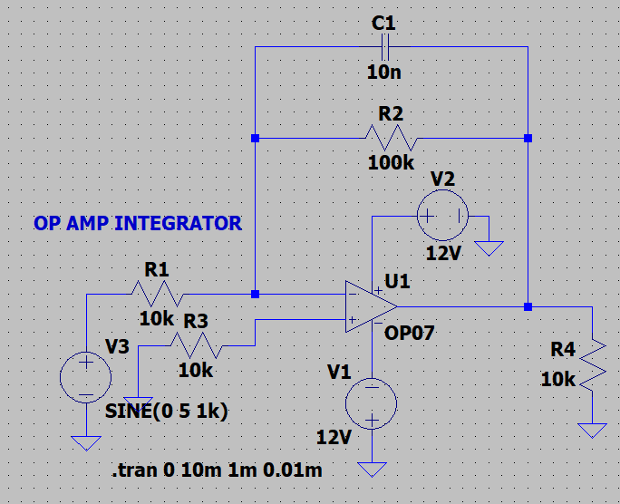

INPUT:

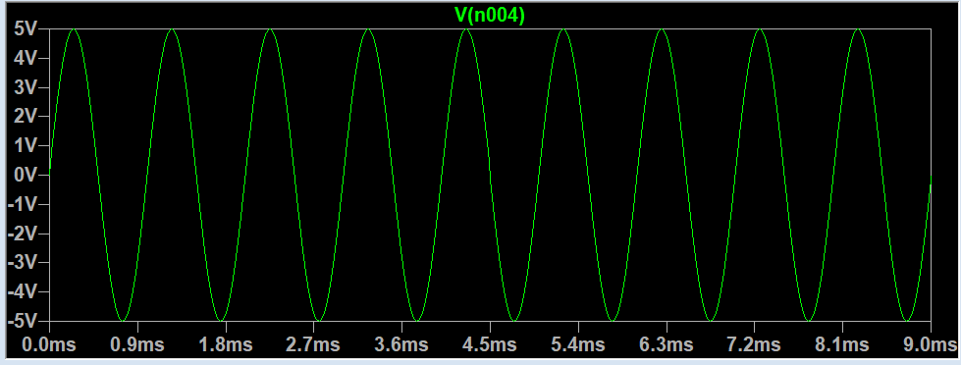

OUTPUT:

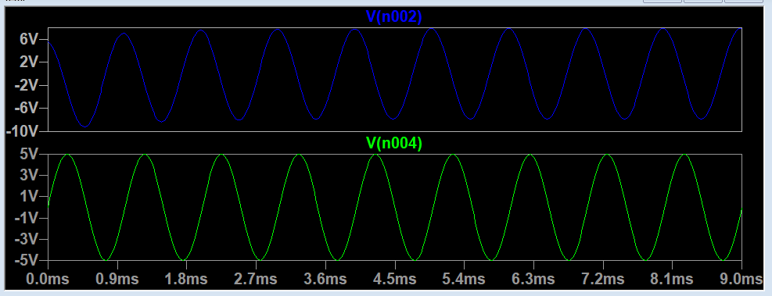

SQUARE IS INTEGRATED:

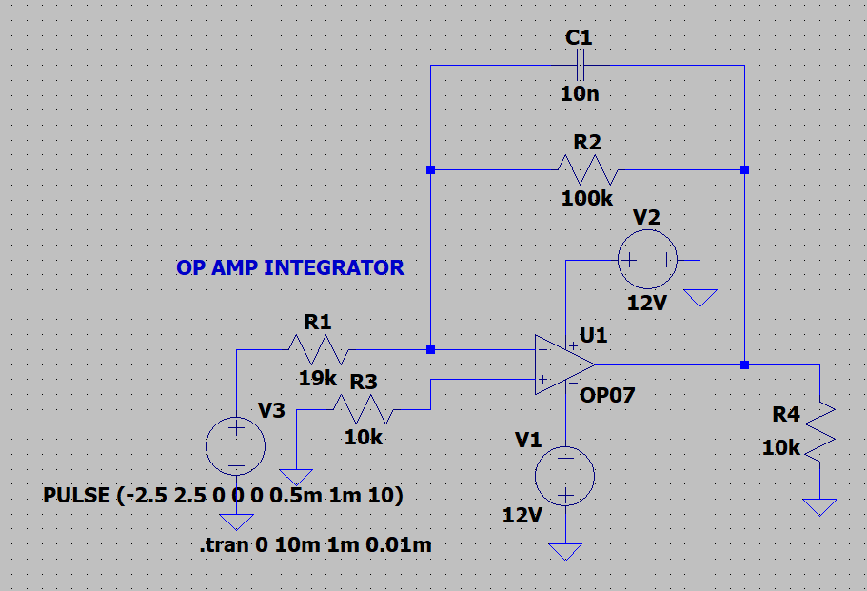

INPUT:

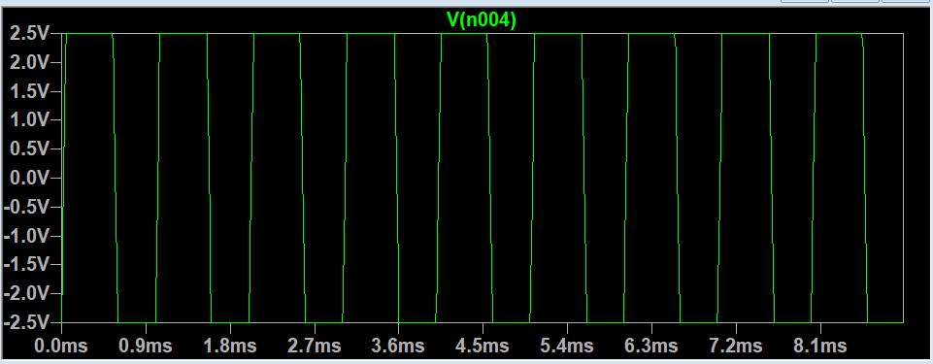

OUTPUT:

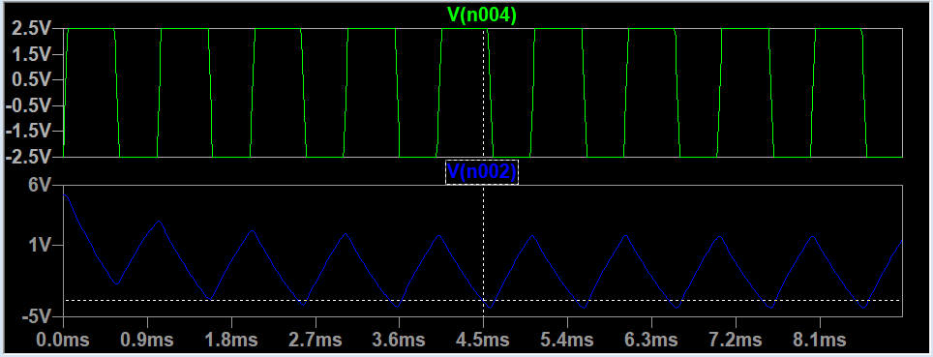

**OP-AMP DIFFERENTIATOR: -**

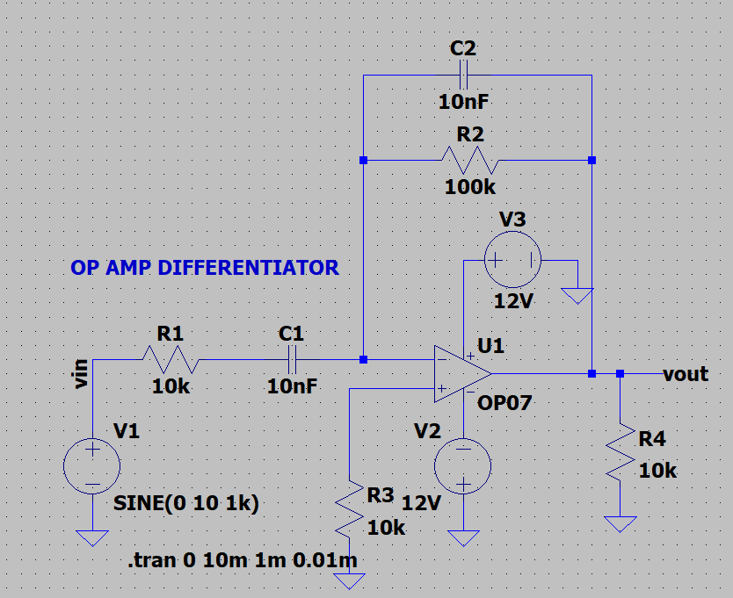

INPUT:

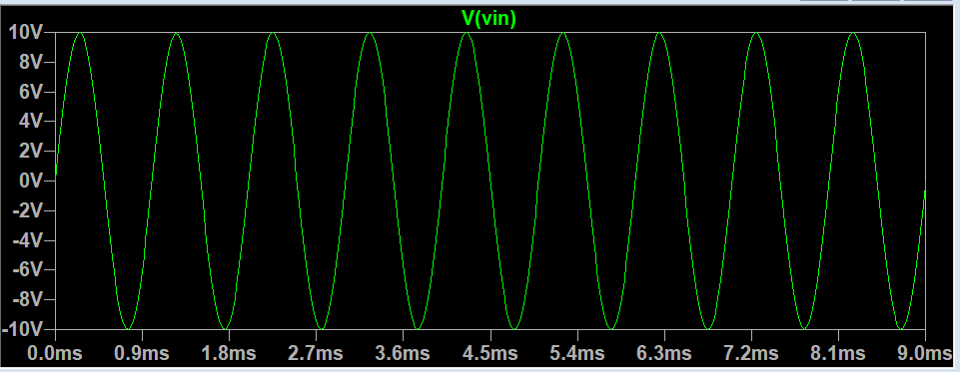

OUTPUT:

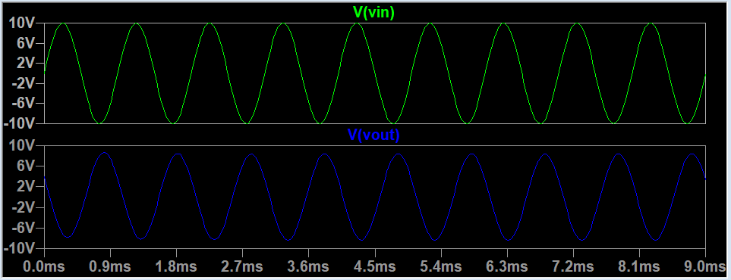

**RESULT: -**

Thus, the inverting, non-inverting summing amplifiers, difference amplifier circuits and op amp integrator and differentiator are designed, tested and verified using LTSPICE.